Findings Analysis

Attribute Selection
Name | Description
Dur | Record total Duration
Proto | Transaction protocol
Service | number of Service “http ftp smtp ssh dns ftp-data”
State | Indicate to state and dependent protocol
Spkts | Source to destination packet count
Dpkts | Destination to source packet count
Sbytes | Source to destination transaction bytes
Dbytes | Destination to source transaction bytes
Rate | -
Sttl | Source to destination time to live value
Dttl | Destination to source time to live value
Sload | Source bits per second
Dload | Destination bits per second
Sloss | Source packets retransmitted or dropped
Dloss | Destination packet dropped
Sinpkt | Source interpacket arrival time (mSec)
Dinpkt | Destination interpacket arrival time (Msec)
Sjit | Source Jitter
Djit | Destination Jitter
Swin | Source TCP window advertisement value
Stcpb | Source TCP base sequence number
Dtcpb | Destination TCP base sequence Number
Dwin | Destination TCP window advertisement value
Tcprtt | The sum of of Synack and Ackdat
Synack | TCP connection setup time between Syn and Syn_Ack packets
Ackdat | TCP Connection setup time between Syn_ACK and ACK Packets
Smean | Mean of packet size transmitted by source
Dmean | Mean of packet size transmitted by destination
Trans_depth | Pipelined depth connection of Http request / response transaction
Response_body_len | Uncompressed content size of data transferred from server Http
Ct_srv_src | No of connection contain same service and destination address in 100 connections
Ct_state_ttl | No of each state according to specific range of value source or destination time to live
Ct_dst_ltm | No of connection the same destination address in 100 connection
Ct_Src_dport_ltm | No of connection of the same source address and destination port in 100 connections
Ct_dst_sport_ltm | No of connection of the same destination address and source port in 100 connection
Ct_Dst_src_ltm | No of connection of the same source and destination address in 100 connections
Is_ftp_login | ftp session is accessed by user and password , 1 is yes and 0 it is no
Ct_ftp_cmd | Number of flow has FTP session command
Ct_flw_http_mthd | Number of flows that has Get and Post for Http service
Ct_Src_ltm | Number of connection of the same source address in 100 connections.
Ct_srv_dst | Number of connection contain same service and destination address in 100 connections
Is_sm_ips_ports | If source and destination IP addresses equal and port numbers then 1 is yes and 0 its no
Figure 1.Features of UNSW-NB15 Dataset
Source : Hamid et al (2018)
the features name of dataset has been shown in table 1 And it has been described it according Hamid et al(2018)
DoS has characteristic to transmit so many data packets to target and it would make a target to make it slower to processes them all. An example of Denial of Service attack by using hping3 as shown in figure 2 and it showing the attribute would be align for this kind attack would be Ct_dst_ltm, Is_ftp_login ,and Ct_srv_dst.
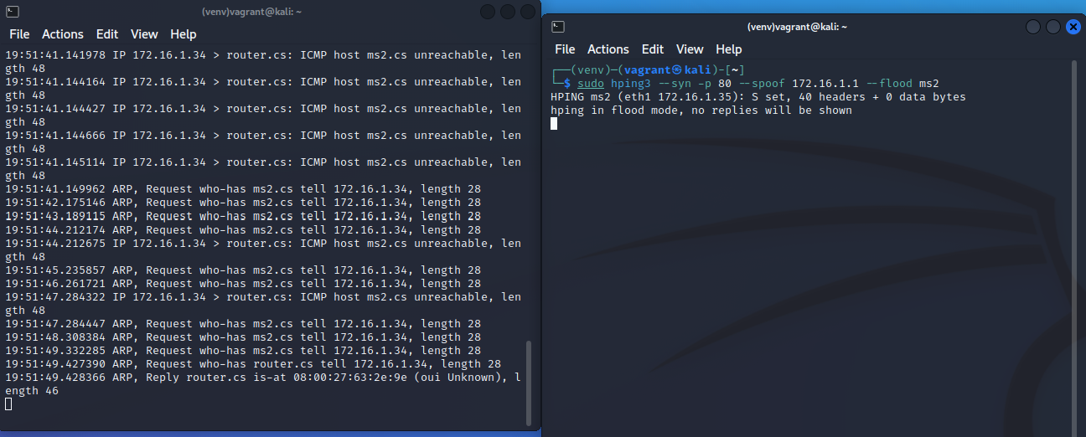
Figure 2. DoS attack

Decision Tree Model
- 52,805 data ( 3 types of attack : DoS,Backdoor,Exploits)
- According study has been conducted by Bujang et al(2024) , the minimum sample size should be at least 30 .
- 36,960 dataset has been tested, tree depth =

Decision Tree Diagram

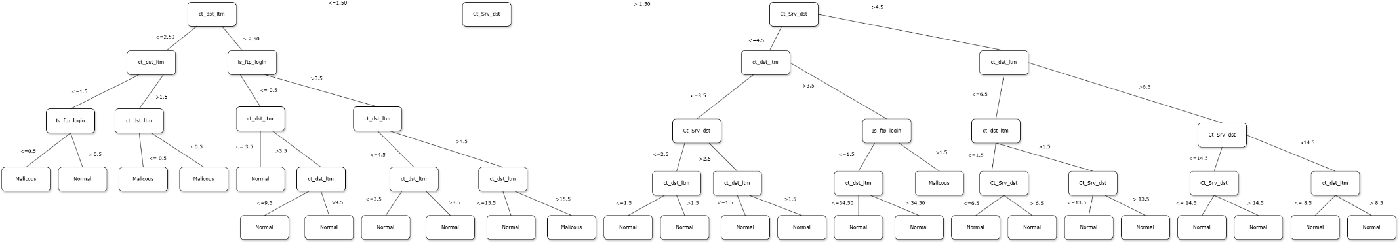
Figure 3. Decision Tree Diagram

Logistic Regression Model
Following selected attribute discussion, then we has labelled UNSW-NB15 dataset into 2 code number which are normal traffic in dataset would be labelled as code number 1 and other type of attacks would be labelled as code number 2 , as shown in table 1.
Number Code | Description
1 | Benign
2 | DoS | Malicious
 | Backdoor
 | Exploits
Table 1 Numeratic Classification

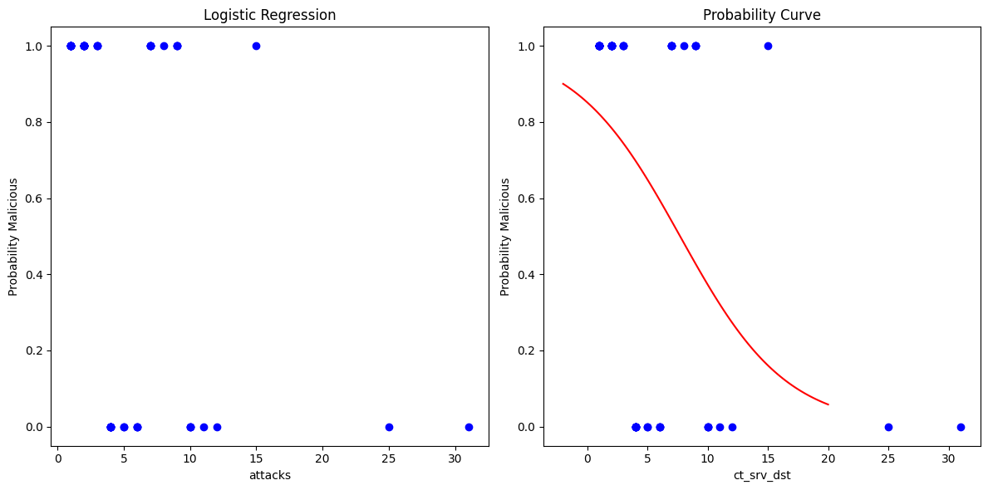

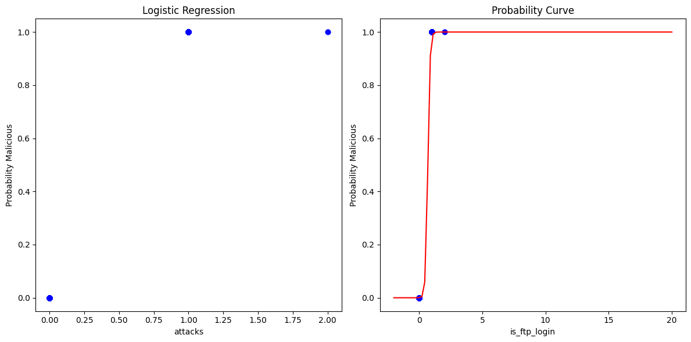

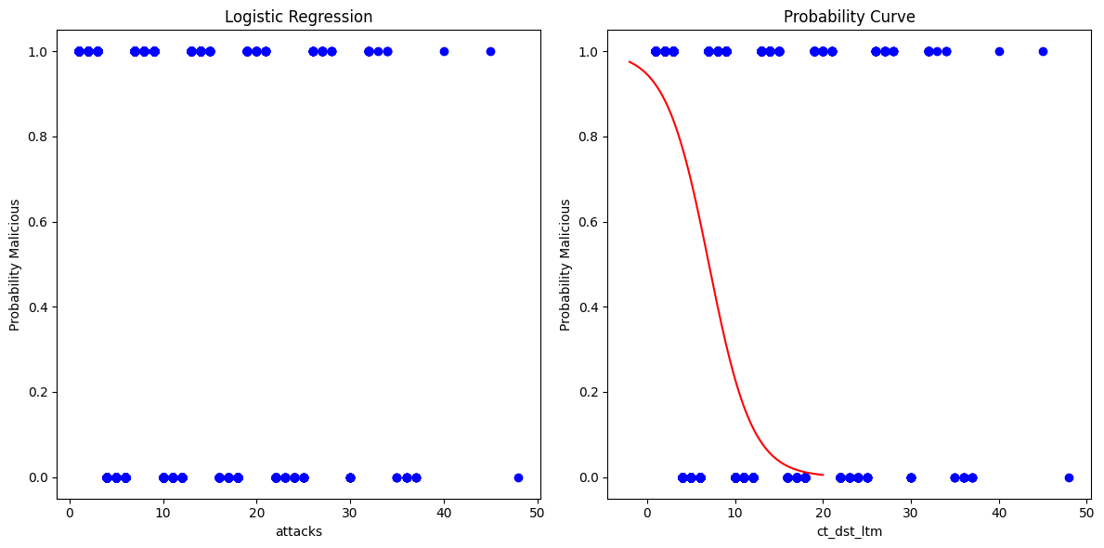

Random Forest Model

Result

Test Case

Confusion Matrix

Decision Tree

Logistic Regression

K-Nearest Neighbors

Performances

Accuracy

Precision

Recall

False-Positive Rate

Comparison Model
Model | Accuracy | Precision | Recall | Fals-Positive Rate
Decision Tree
Logistic Regression
Random Forest

Equation :

Confusion Matrix

False Positive Rate:

References
Bujang, M. A., Omar, E. D., Foo, D. H. P. & Hon, Y. K., 2024. Sample size determination for conducting a pilot study to assess reliability of a questionnaire. Restorative Denstistry and Endodontics, Issue 49.
Hamid, Y., Ranganathan, B., Muthukumarasamy, S. & Journaux, L., 2018. Benchmark Datasets for Network Intrusion Detection: A Review. International Journal of Network Security, Volume 20.

